Paulius Kuzmickas

Rony Portelli

Ioan Luca

**Meeting Manager**

**Interim Deliverable**

**Introduction**

The assignment is to create a meeting manager which allows the users to create their electronic diaries. The electronic diaries allow them to record details of any meetings that they have. For this project we are going to use an object orientated design implemented in Java, the Agile methodology for software development via Pivotal Tracker and tools like GitHub for version control.

**Requirements**

**Functional:**

* Each user should have their own electronic diary
* The user should be able to add, edit and delete events and tasks in the diary
* The system should have an undo feature
* The user should be able to see a visualized version of their diary in an Agenda, Day, Week and Calendar view
* The system should accept local users by saving and loading data from the disk drive
* The system may store the user’s data in a database
* The system may integrate Google authentication through Google API
* The system should have a search function that allows the user to search for specific tasks and meetings in a specified time range
* The system should be able to record the time taken to search the diaries
* The system should have a graphical user interface
* The user should be able to apply reminders to their tasks and events
* The user should be able to make a reminder repeat
* The tasks in a user diary should have a description and a priority

**Non-functional:**

* The system should be cross-platform
* The system should be memory efficient
* The system should be good performance wise, use suitable data structures algorithms
* The system should be portable in the sense that it will not require an installer
* The system may keep track of user’s behaviour for determining the user tendencies

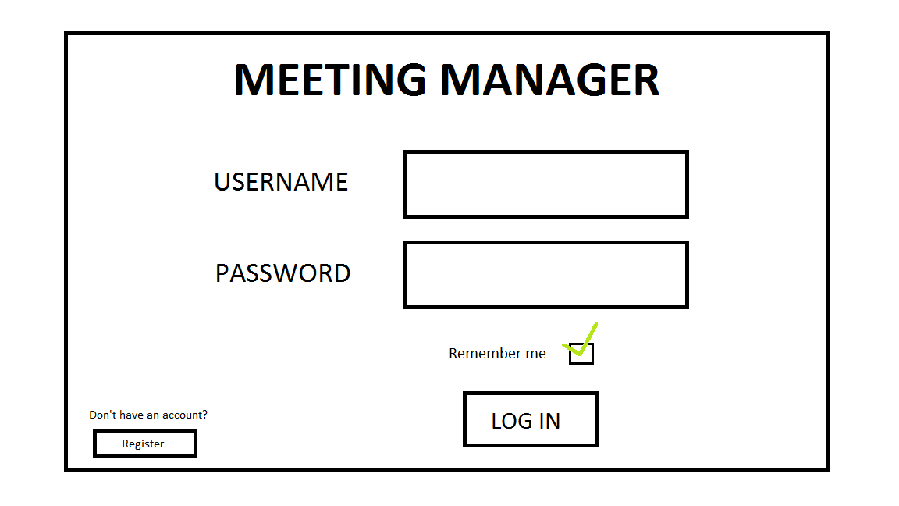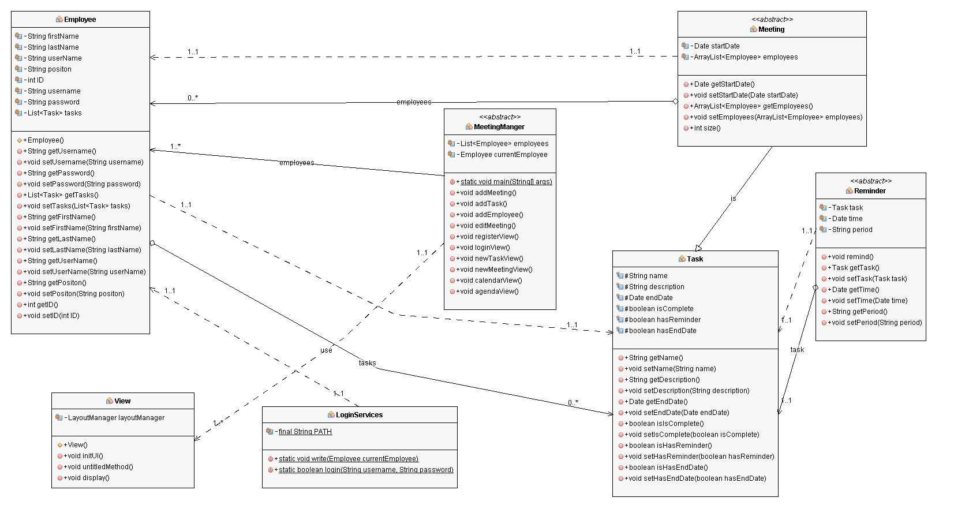**Design**

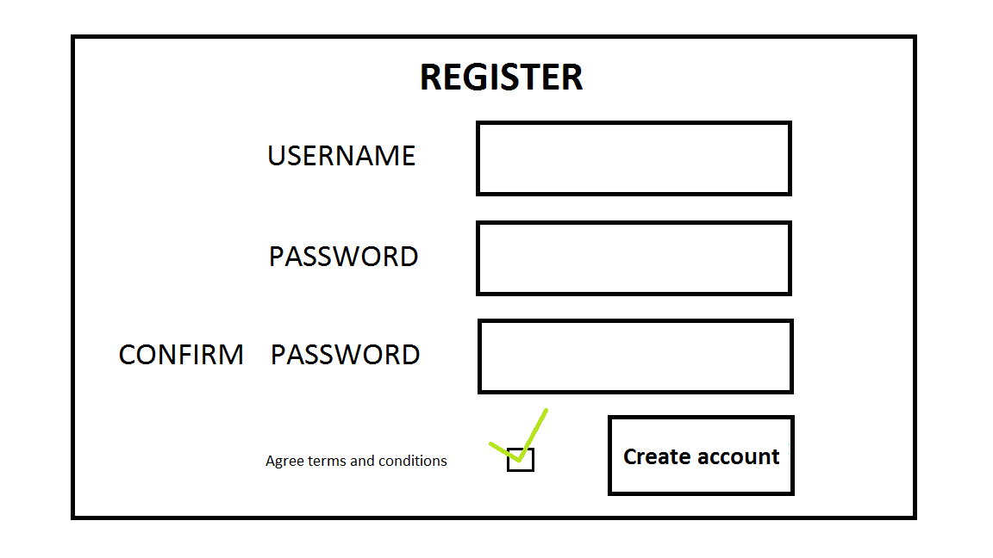

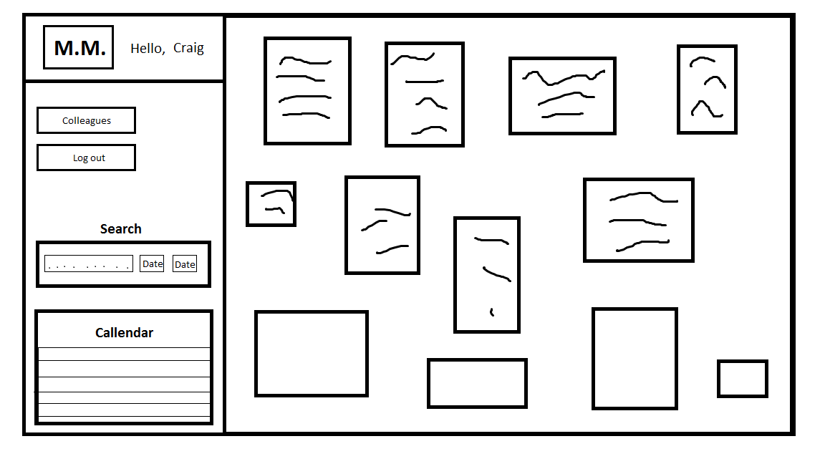

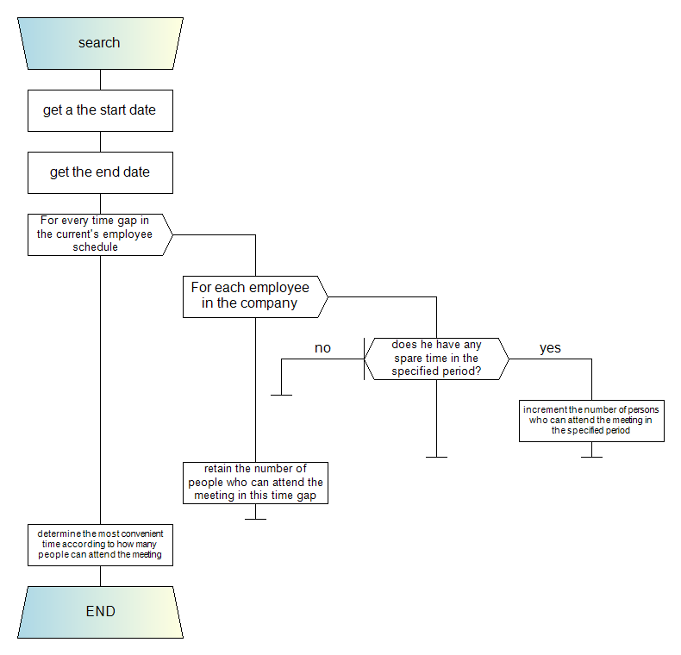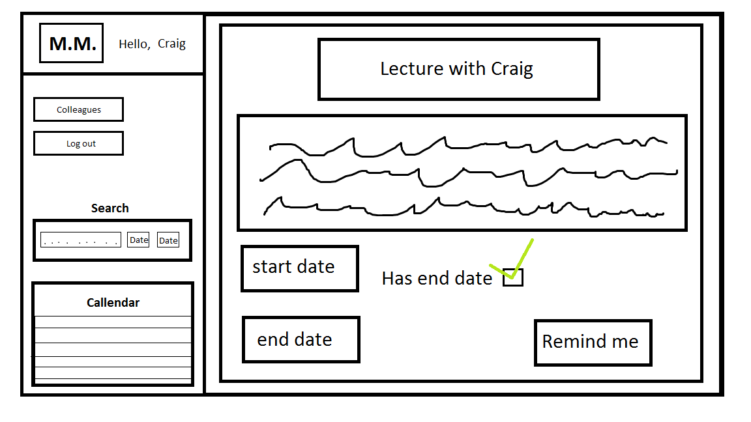

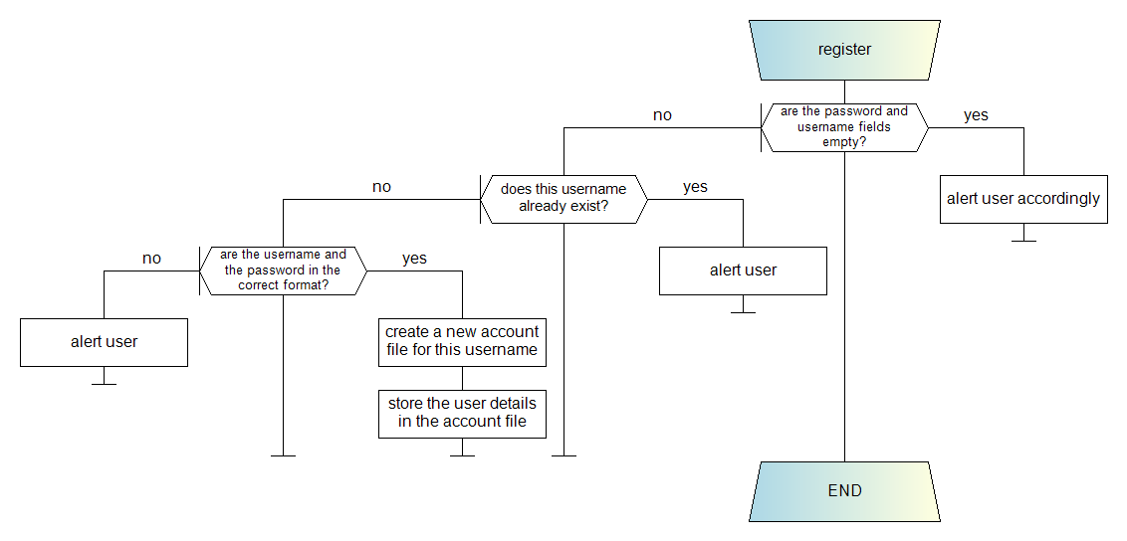

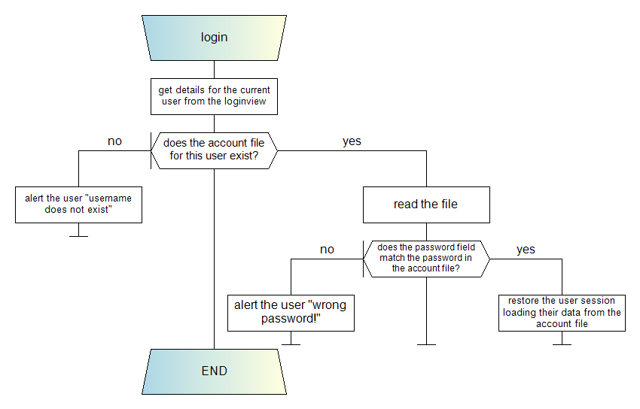

**Task allocations**

Most of the team tasks will be allocated as we work for the project since we will try to follow some core principles of the Agile methodology. We will try to simulate scrum meetings where we can establish sprints that will need to be finished until the next team meeting. Therefore, the tasks will be allocated between us according to their difficulty and our availability as well.

We are going to use the <https://www.pivotaltracker.com> as a project manager. We chose it because we want to get used to various tools such as this one and because it can be integrated with Slack, the team chat platform that we are using. View access to our project on Pivotal Tracker is available on request.

We are going to use GitHub as a version control tool and we’ll do our best to write clear and commented code that can easily be understood. We will also make sure that each of us will commit source code regularly including relevant commit messages and that only released features will be pushed to the master branch.

For our next meeting we’ve established the following tasks:

* Rony – use cases for our program
* Paulius – start implementing the GUI
* Ioan – work out the register/login service logic